Devin Fowler

09/21/2017

Lab 2 Report

Step 1: Introduction to Roll-a-Ball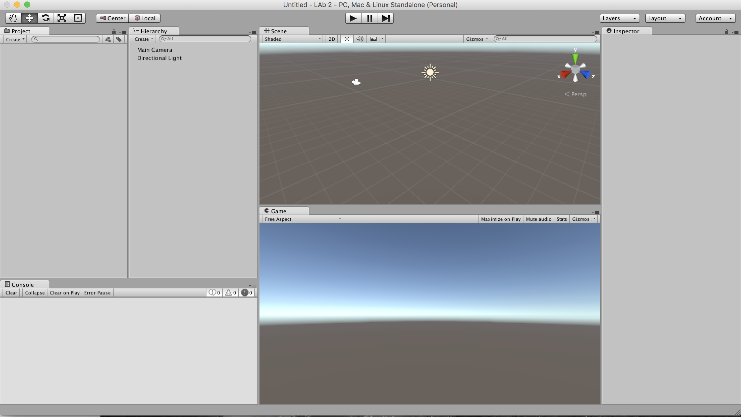

Step 2: Setting up the Game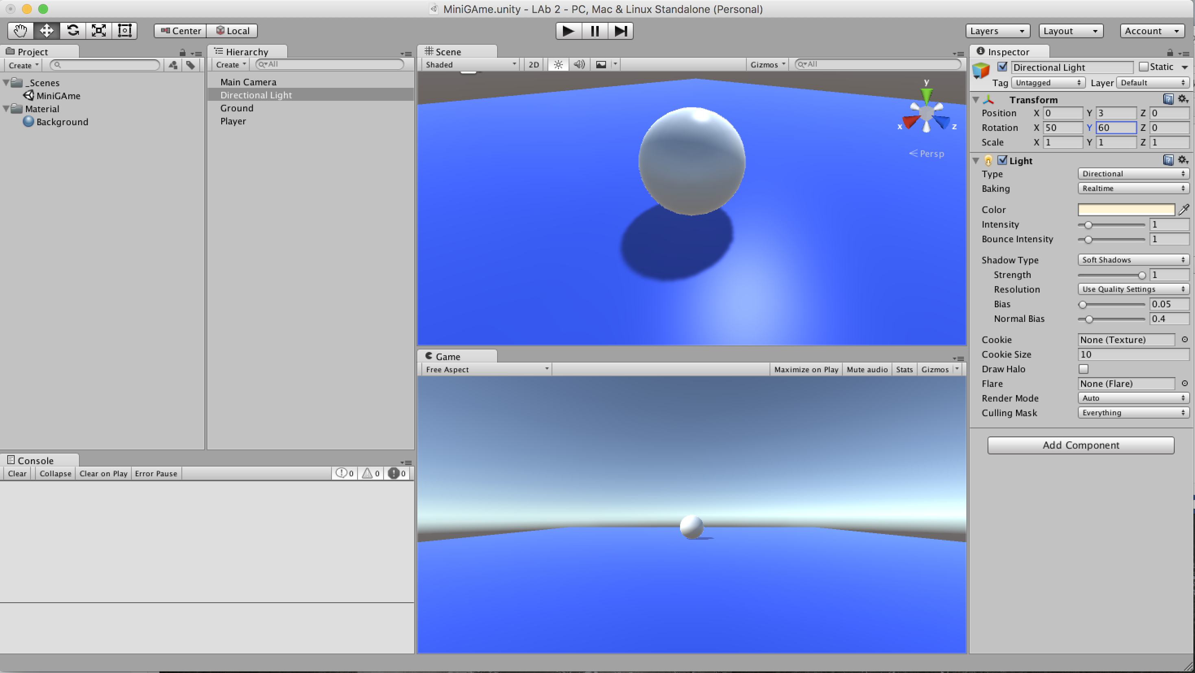

Step 3: Moving the Player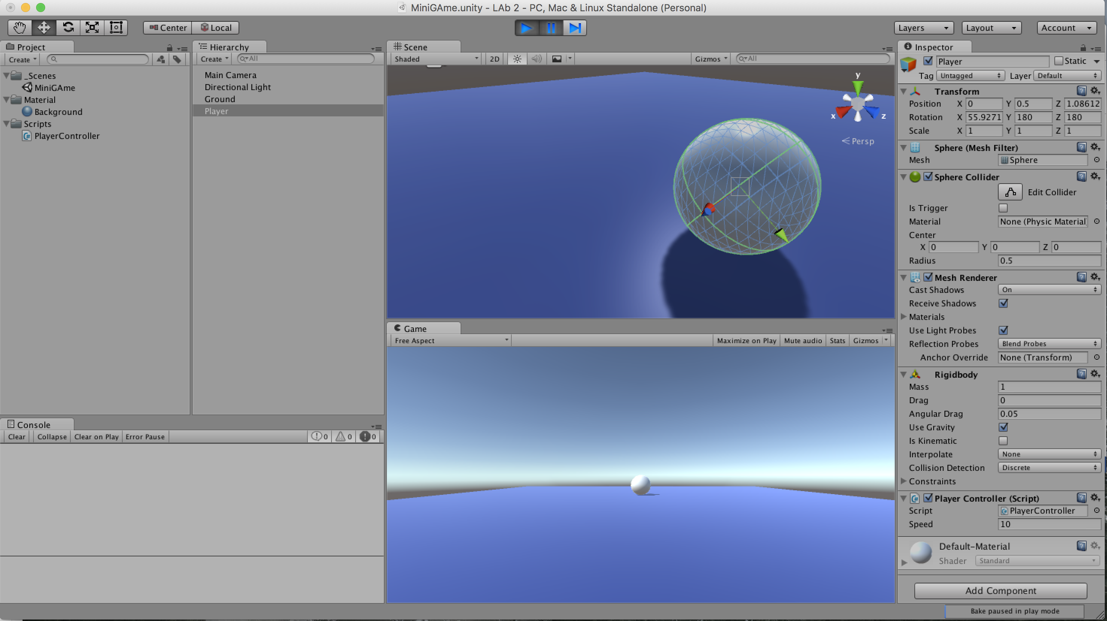

Step 4: Moving the Camera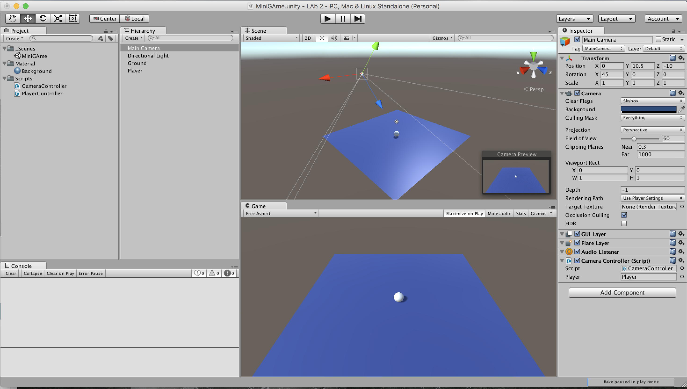

It was diffiult to find out how to move the pov of the space around so that you can see from different angles.

Step 5: Setting up the Play Area

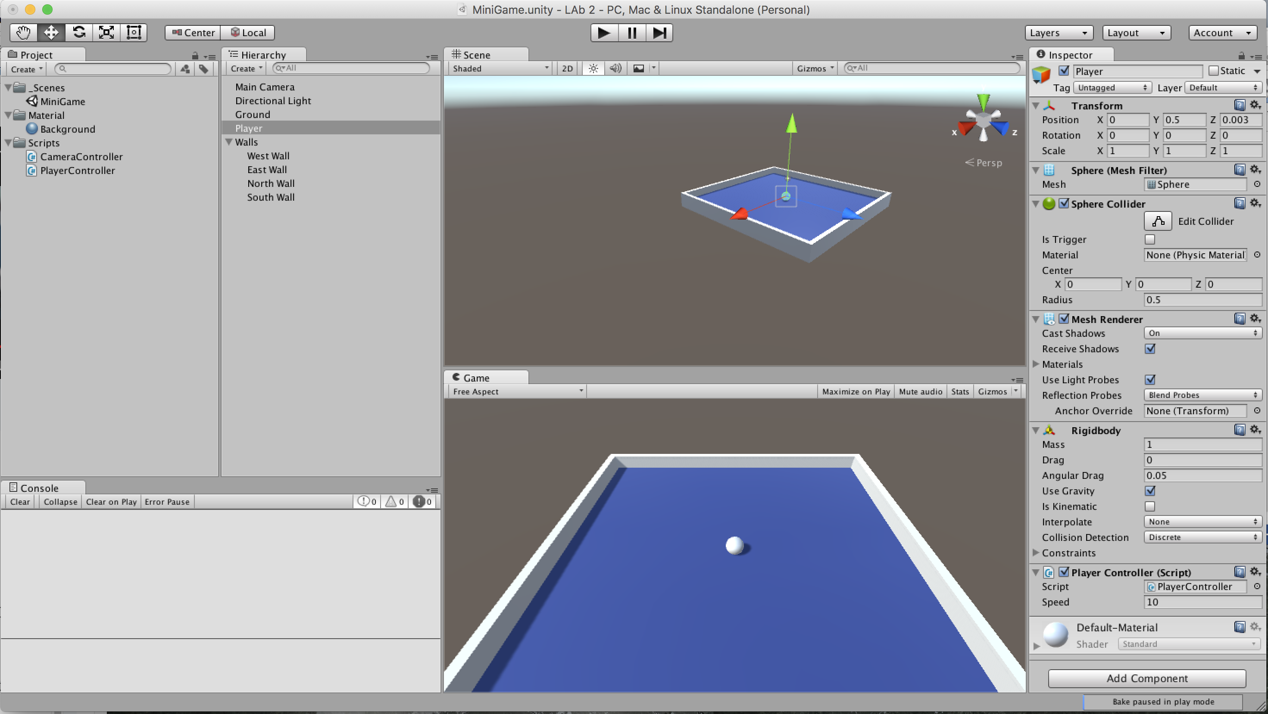

At first I tried dragging the walls into the correct spot, but that proved to be more difficult than I thought, so I just used the x and y values provided.

Step 6: Creating Collectable Objects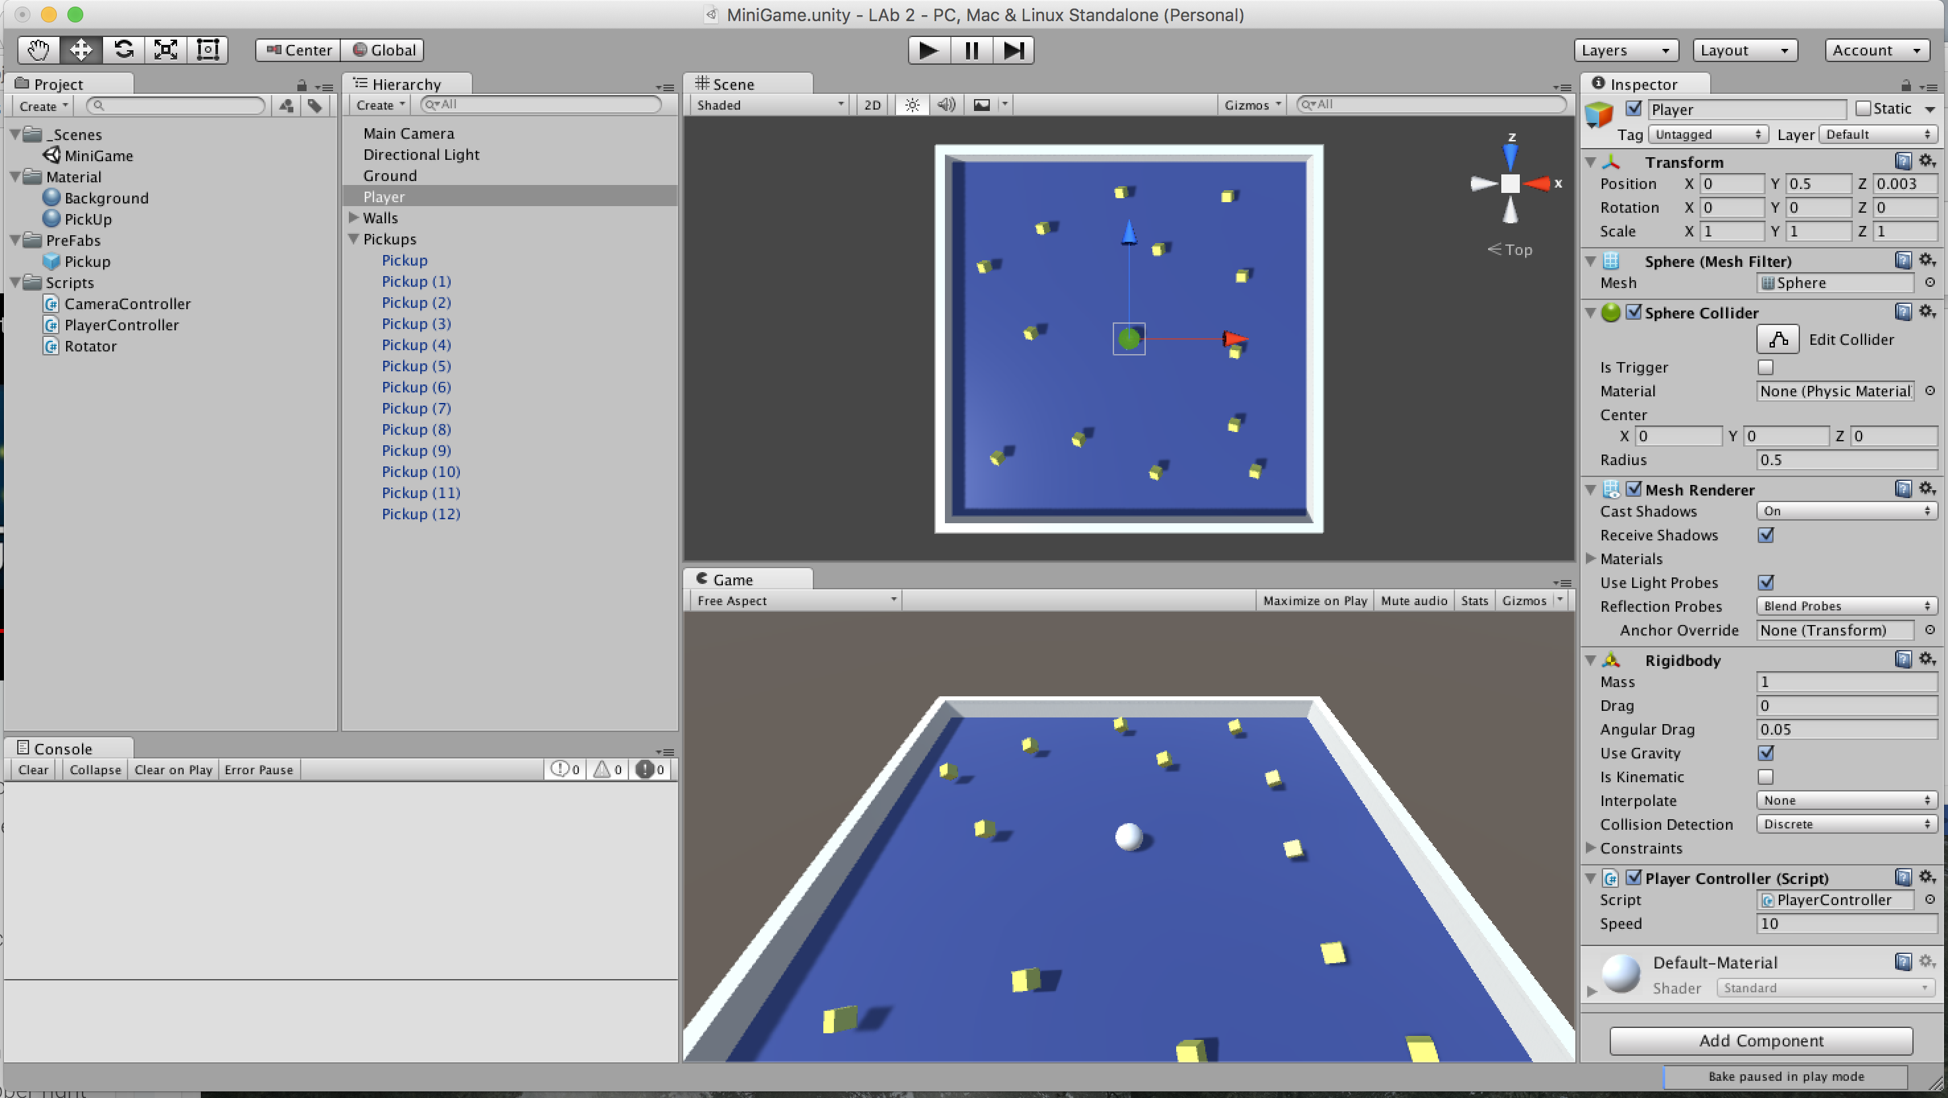

Step 7: Collecting the Pick up objects

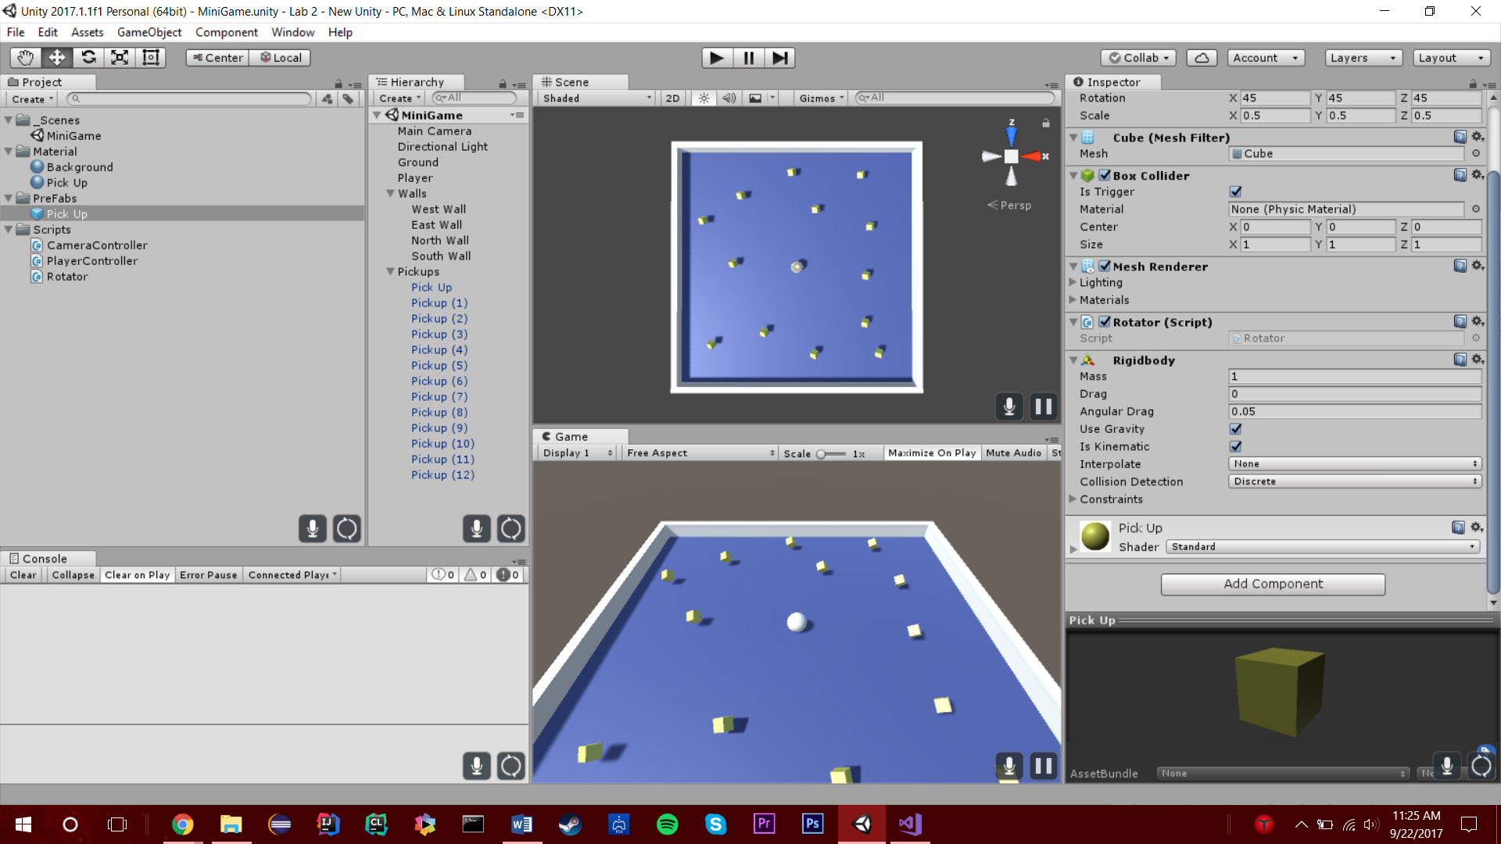

Step 8: Displaying the Score and Text

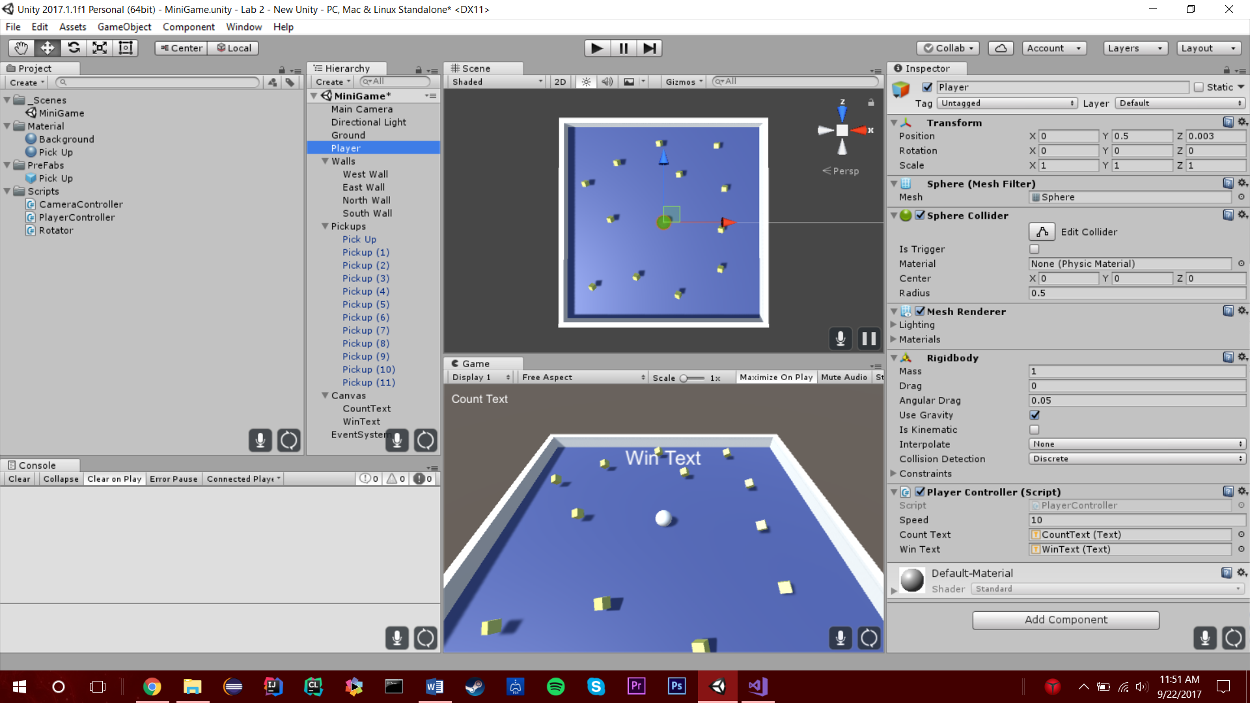

Getting the score text into the correct spot was difficult, I had to mess with the location to get it into the corner.

Step 9: Building the Game

